I used Databricks for all my queries.
Question 1
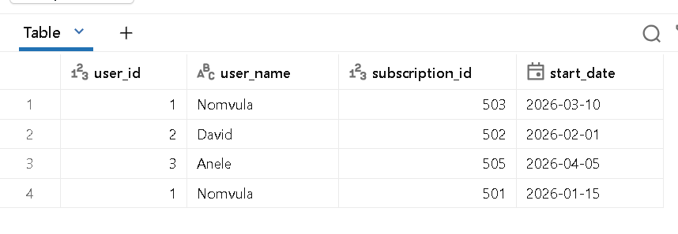
Question 2
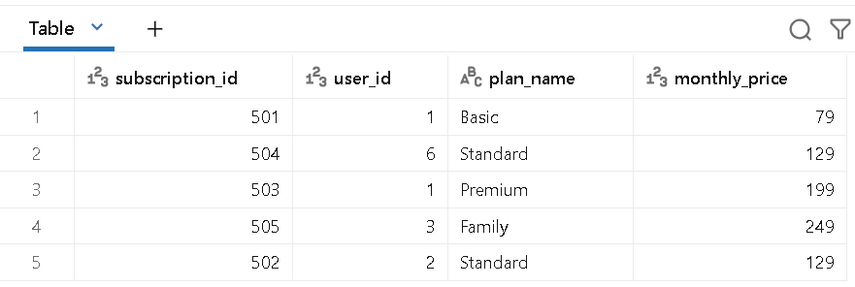

Question 3
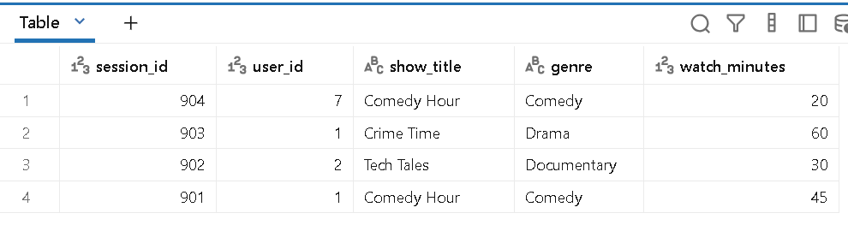
Question 4
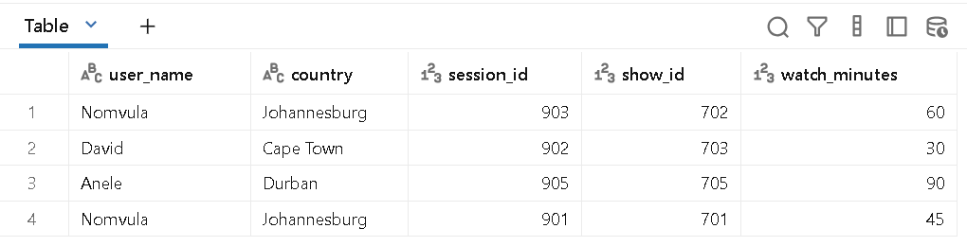

Question 5
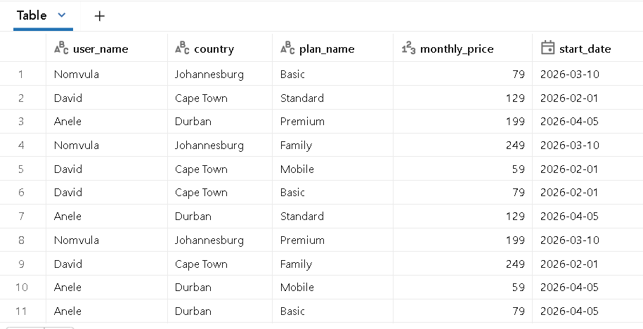
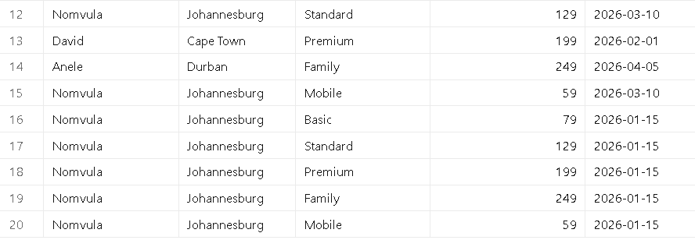

Question 6
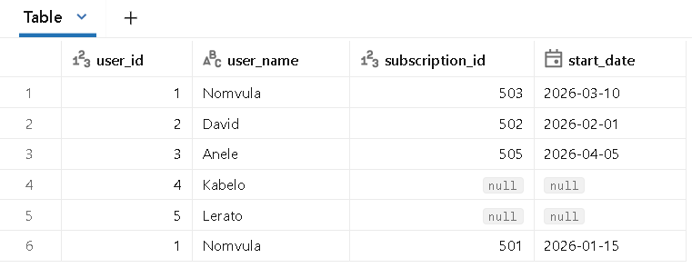

Question 7
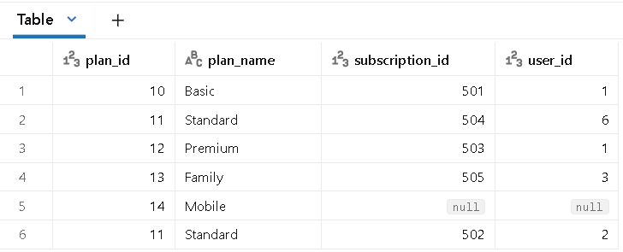

Question 8
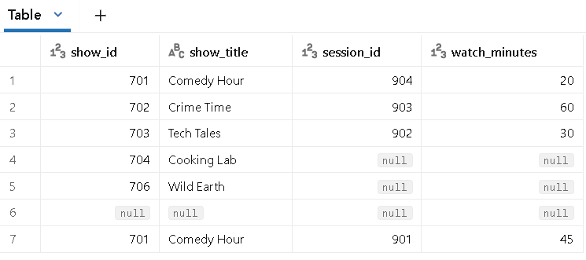

Question 9

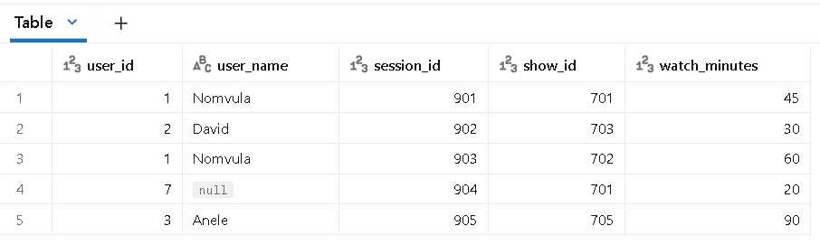

Question 10

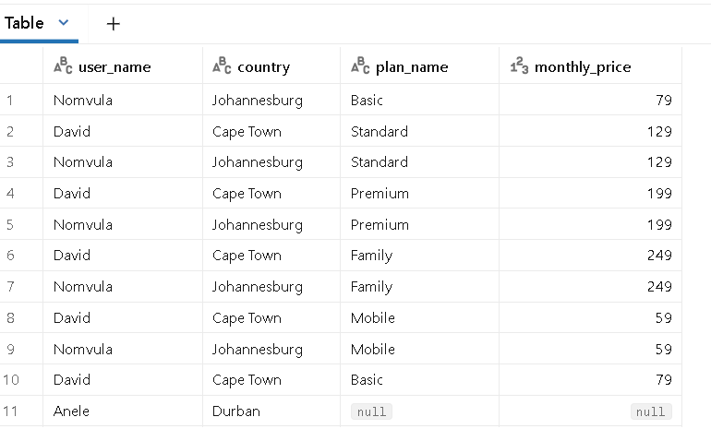
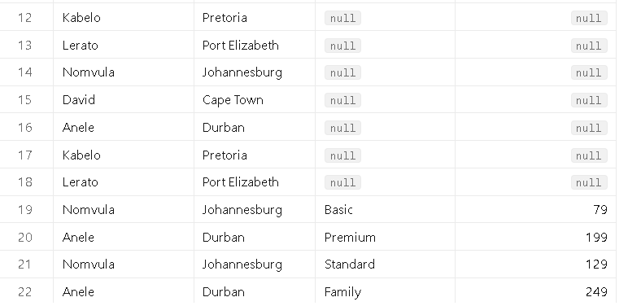
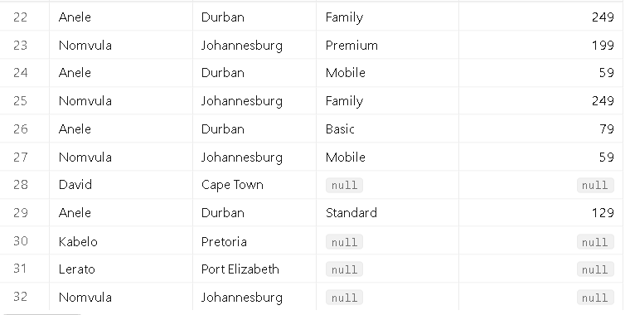
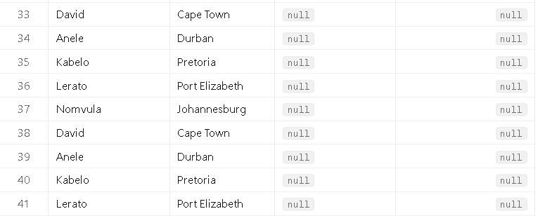
Question 11
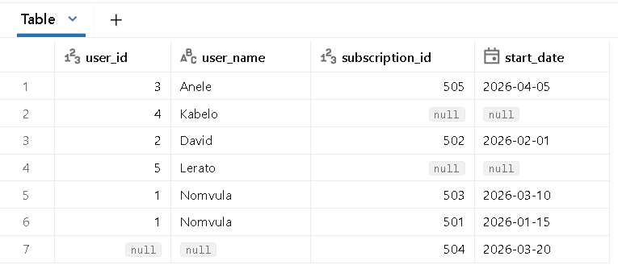

Question 12

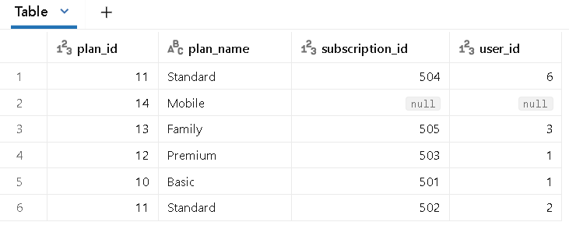
Question 13

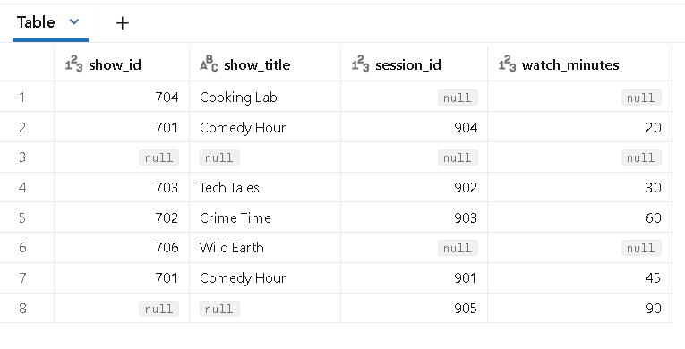

Question 14
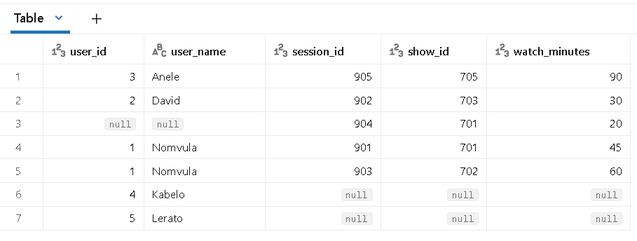
Question 15
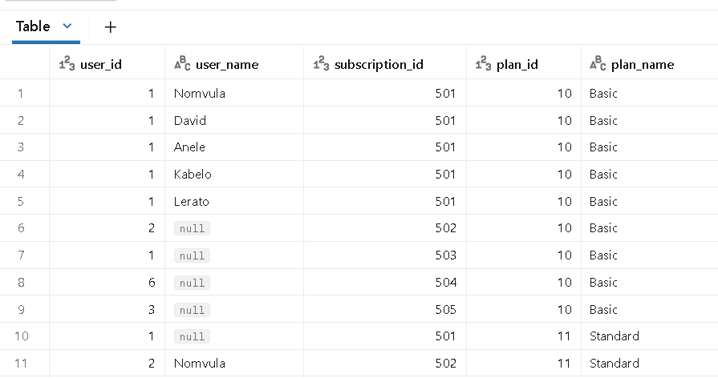
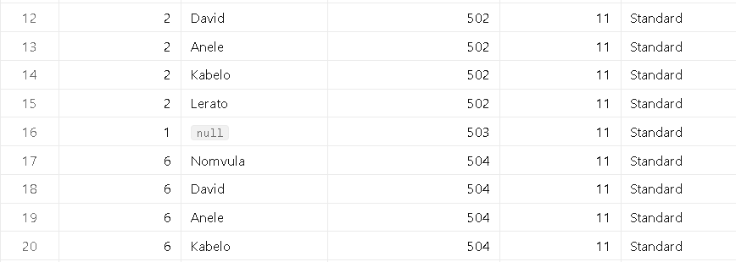
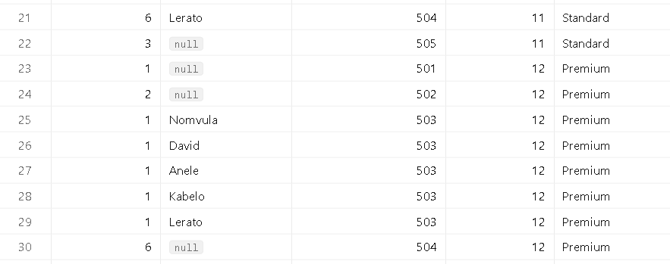
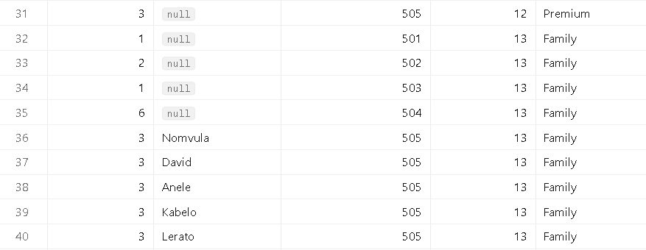
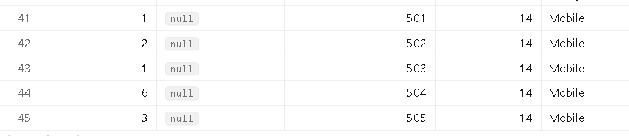

Bonus challenge

User_id | User_name | Country
4 | Kabelo | Pretoria
5 | Lerato | Port Elizabeth

2.
Subscription_id | User_id | Plan_id | Start_date
504 | 6 | 11 | 20/03/2026

3.
Show_id | Show_title | genre
704 | Cooking lab | Lifestyle
706 | Wild earth | documentary

4.
Session_id | User_id | Show_id | Watch_minutes
905 | 3 | 705 | 90

5.
Plan_id | Plan_name | Monthly_price
14 | Mobile | 59

